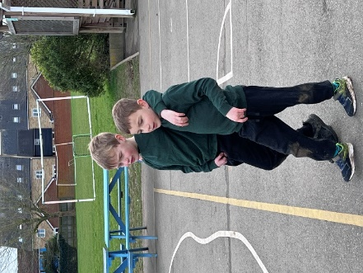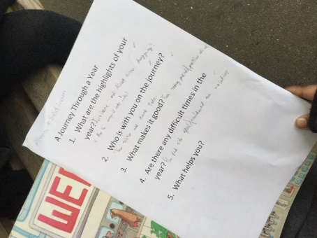
Walk and Talk with Mrs Crane and English interview in the open air.
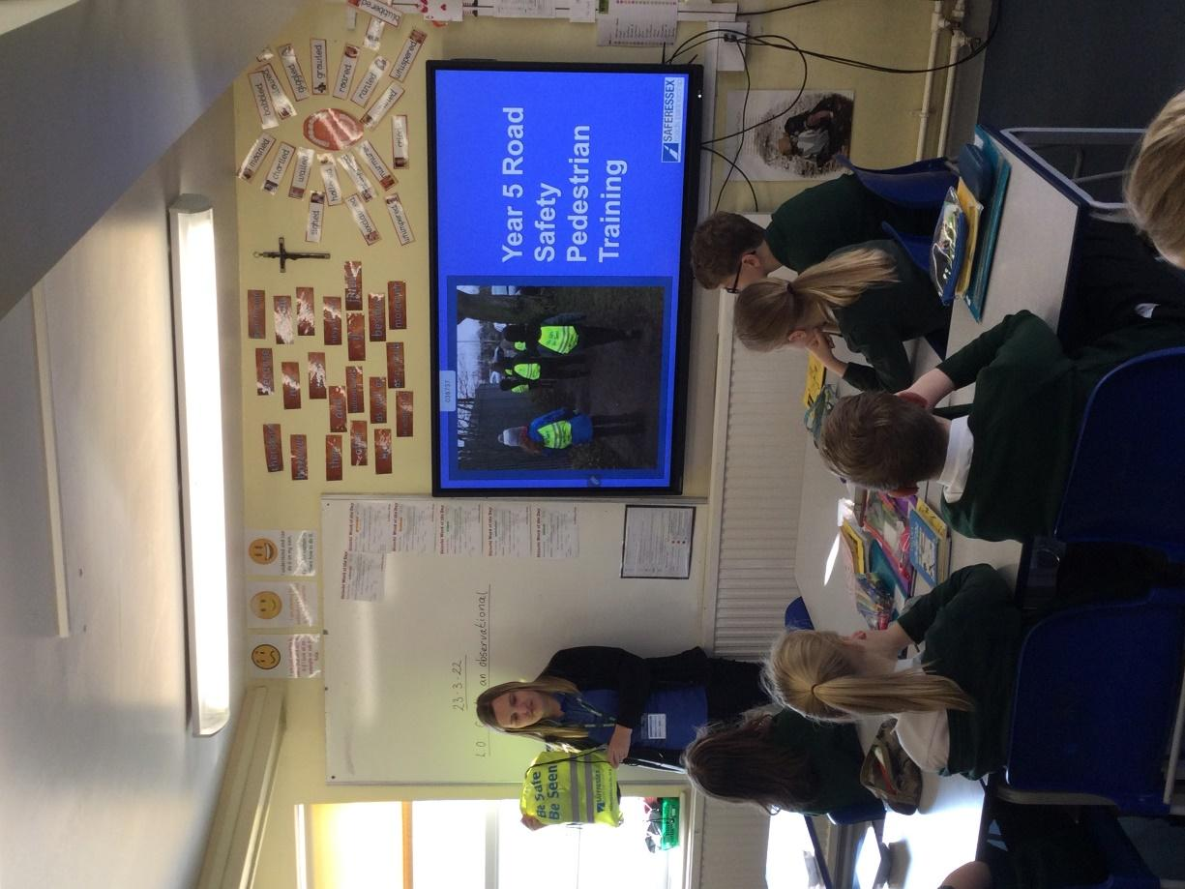 On Thursday, Miss Woodruff from Safer Essex Road Partnership came in to talk with Year 5 about road safety. The children learnt all about how to look for dangers on the road, what different lights on a car mean and all about different ways to cross a road safely. They also went out in small groups and demonstrated how they need to stop, look, listen and think before crossing the road. Each child was given a high vis bag to take home too. A very informative and hugely important session, thank you very much to Miss Woodruff.
Autumn and enjoying Spanish culture with a chocolate con churros.
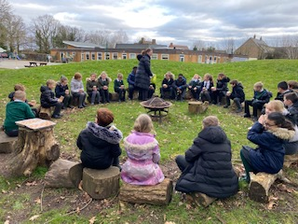
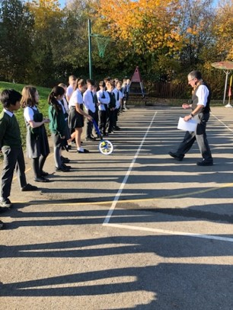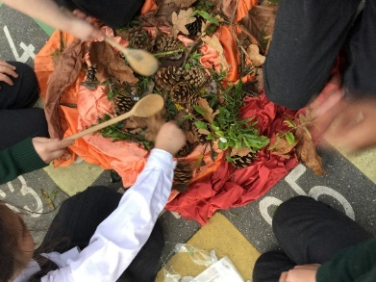
Stephen from Victrix supporting understanding the Victorians in our playground.
What was it like to gather during the Stone Age?

